[**How to create a Wiki page**](https://sharepoint.rackspace.com/Learning/Articles/Pages/SharePoint-2013--how-to-create-a-wiki-page.aspx)

What is a SharePoint Wiki Page?  A SharePoint Wiki page is commonly used to easily share information and collaborate with other users.  Many people use these pages because of the simplicity, both creating and editing.  Maybe you want to put important company information on this page or instructions on how to do something. Either way, Wiki pages provide a quick way of adding text to your SharePoint site.

1. From your SharePoint site, in the upper right click the Site settings gear.

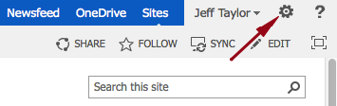

2. From the drop-down click Add a page.

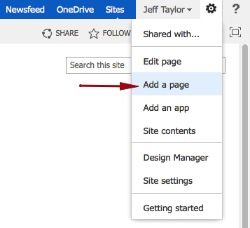

3. Under New page name: give it a name, in this example I will call mine “Site Upgrade”.

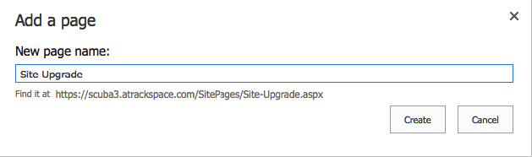

4. Click Create.

https://sharepoint.rackspace.com/Learning/PublishingImages/How%20to%20create%20a%20Wiki%20Page/createwikipage4.png

5. Enter an content you would like, in this example I will put “Coming soon to a SharePoint site near you!”.

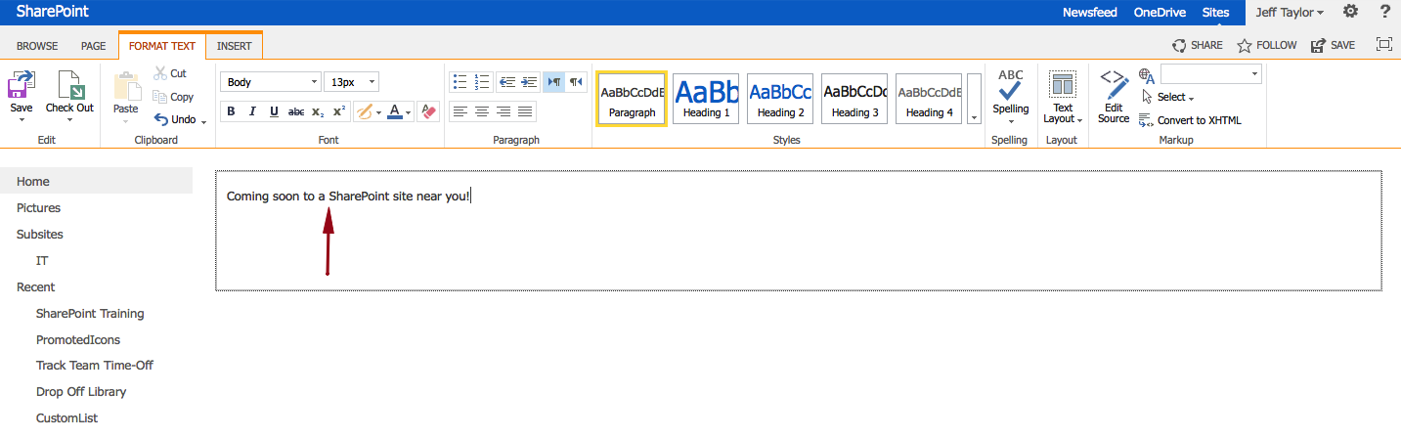

6. In the upper left click Save.

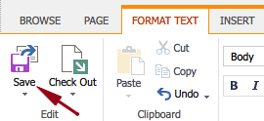

The page will save and that’s it.

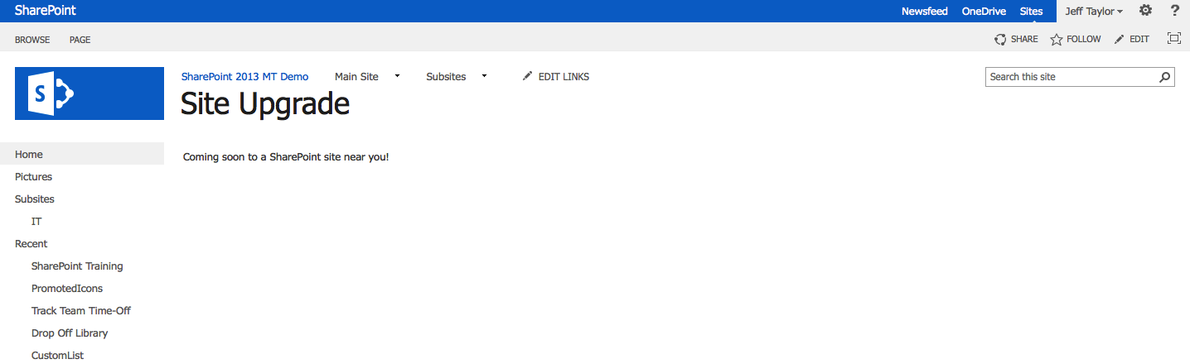

In the tutorial “How to edit a Wiki Page” I will show you how to locate this page if you have forgotten the URL and also how to make an edit.